Sri Siddhartha Dental College & Hospital
Agalakote, Tumkur-572107
Annual report- committee for cultural & co-curricular activities
Academic year of 2019-2020

Aayudha Puja Celebration– 2019
Aayudha pooja was celebrated on 5th October 2019. This year too all the departments were adorned with festive look. There were theme based decorations, all the staff and students decorated department with rangolis, flowers, lightings, plantain twigs, mango leaves and many other different innovative ways. There were various theme based decorations such as gender equality, save earth, forest fire, floods, draught and festivals of India etc. The college was filled with festive spirit. Though the Best decorated department was honored with Prize, principal was overwhelmed by the enthusiastic participation of all and rewarded all other departments including library, office, stores and canteen with special consolation prizes. Prizes were awarded to best dressed students and staff too.
Prize winners were
1st prize- Department of Oral Surgery
2nd prize-Department of Pedodontics
3rd prize-Department of Periodontics

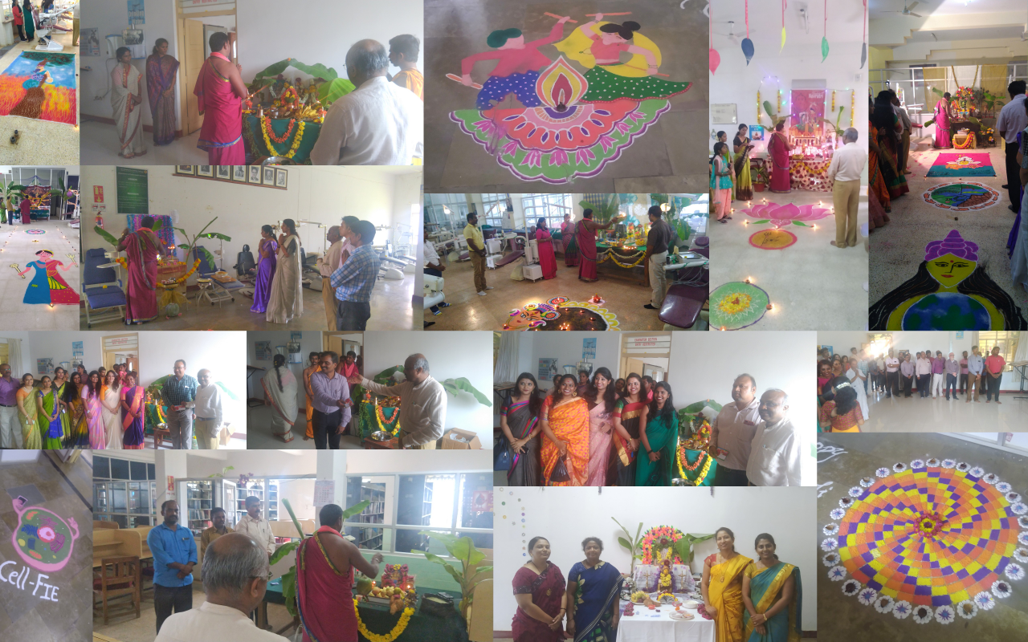

Genesis –2019
Cultural events were oraganised on 12th and 13th October 2019. Cultural Events for 1st BDS students were on 12/10/19 - FRESHERS DAY and Cultural Events for all other students was on 13/10/19 – CULTURAL DAY. There was one week of various competitions conducted before fresher and college day the prizes for which are awarded on 13th October 2019.

The events conducted are as follows
Date | Event | Event coordinator
01.10.2019 | Mad-ads | Dr.Kokila&Dr.Shubha
 | Drawing and painting
 | Face painting
03.10.2019 | Essay writing | Dr.Darshana& Dr. Likhitha Swamy
 | Collage
 | Rangoli
09.10.2019 | Fashion show | Dr.Pavana& Dr. PreethiBhat
 | Dance
 | Lazy dance
10.10.2019 | Instrumental music | Dr.Kiran&Dr.Praveen
 | Singing – solo
 | Skit
11.10.2019 | Flower bouquet arrangement | Dr.Pavana& Dr. PreethiBhat
 | Dumb charades
Last date for Submission 10.10.2019 | Short Film Making | Dr.Kokila&Dr.Praveen
 | Photography
 | Poetry Writing

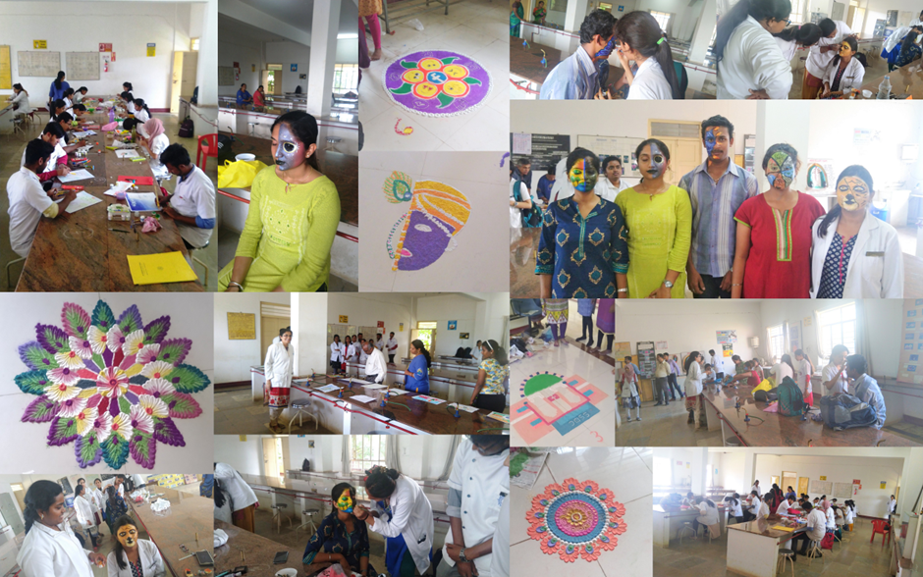
The list of prize winners
Sl no | Events | 1st prize | 2nd prize | 3rd prize
1 | Drawing & painting | Priyanka&  Haripriya | Prekshasinha | Harshitha.A
2 | Face painting | Vrunabakshi | Haripriya&  Dr.Pranjal | Dr.Hema
3 | Essay writing | Vrunabakshi | Shobhana | Moulya
4 | Collage | Vrunabakshi, Divya, Shivangi | Harshitha, Bhoomika, Faizuddin | Akash, Syed Moufez, Snigdha
5 | Rangoli | Ayushi, Harshapriya,  Harshitha | Dr.Kokila,  Dr.Shubha  Dr.Chethana | Hemanth, SyedaMisbah, Meghana
6 | Dance(group) | Moulya,bhoomika,syedmizbha
7 | Singing - solo | Krishna Gayatri | Denver | Moulya
8 | Skit | Megana, Mizba, Moulya, Bhoomika, Nikitha, Afshinfathima,  Preksha, Hemanth
9 | Photography | Dr.Supriyo pal | Preetam | Ankurdatta
10 | Short film making | Alex das, Harishankar
11 | Poetry writing | Syed moufez (eng)  Layashree (hindi) | Anusha.R (eng) | Moulya RK (eng)
12 | Dumb charades | Mizba, Moulya, Md. Faizuddin, YashasNaik | Dr.Likhitha,  Dr.Archana,  Dr.Darshana  Dr.Mahalakshmi  Dr.Shubha  Dr.Chethana | Vismaya  Krishna  Megha  Shirin

Program list on the FRESHERS DAY on 12/10/19
- Group dance “retro to metro” by Madhumita, Bhoomika, Niharika, Souvik, Denver, Pranov.
- English Solo song “Rolling in deep” by Aditi Prasad
- Solo dance “Abdhuzada” by Reshmaraj
- Solo dance “remix” by Madhumita
- English Solo song by Bidita
- Hindi duet song “tu hi re” by Shobhana& Denver Yohan
- Fashion show
Program list on the CULTURAL DAY on 13/10/19
- Group dance “crazy kiya re” by Moulya, Boomika&Mizba
- Group dance “mayyamayya” by Avipatel,vismaya, Krishna gayathri, shazia&nishtha
- Group dance “barsoremegha” by staff & PG students
- Group dance “o sakisaki re” by Moulya, Armeen, Shivangi
- Solo folk singing by non-teaching staff Shivamma
- Skit by 2nd BDS students
- Solo dance by PG student Dr.SwagathikaPradhan
- Solo Singing by Krishna gayathri
- Fashion show by PG students

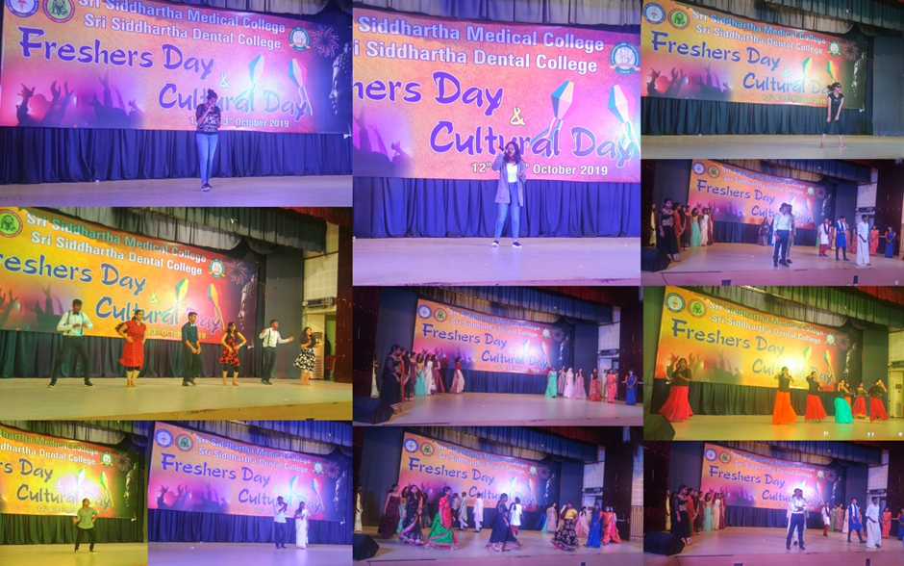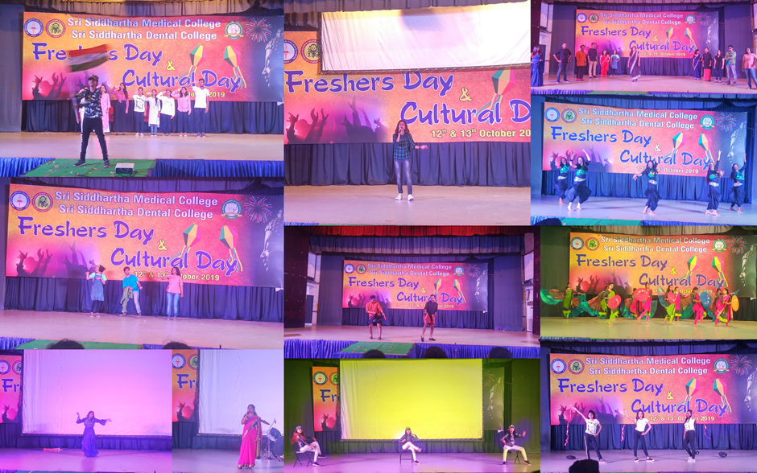

International Men’s Day –2019
INTERNATIONAL MEN’S DAY was organized by committee for cultural and cocurricular activitieson 19th November 2019 at AV Hall of Sri Siddhartha Dental College Hospital Tumakuru. All the lady staff of the college were enthusiastically involved in organizing the event. The program included welcome address by Dr.Kokila, chairperson, committee for cultural and cocurricular activities followed by few words by Principal, SSDC - Dr.K.R.Kashinath. Various fun games were organized by Dr.Pavana, Dr.Likhitha Swamy, Dr.PreethiBhat, Dr.Shubha and Dr.Darshana for the male staff of the institution such as copycat, aiming the ball, musical chair, balloon balancing race, antyakshari followed by cake cutting. All the staff participated and enjoyed the fun filled games. In the end the events were followed by snacks for all the staff and students which were arranged by all lady staff of the college.

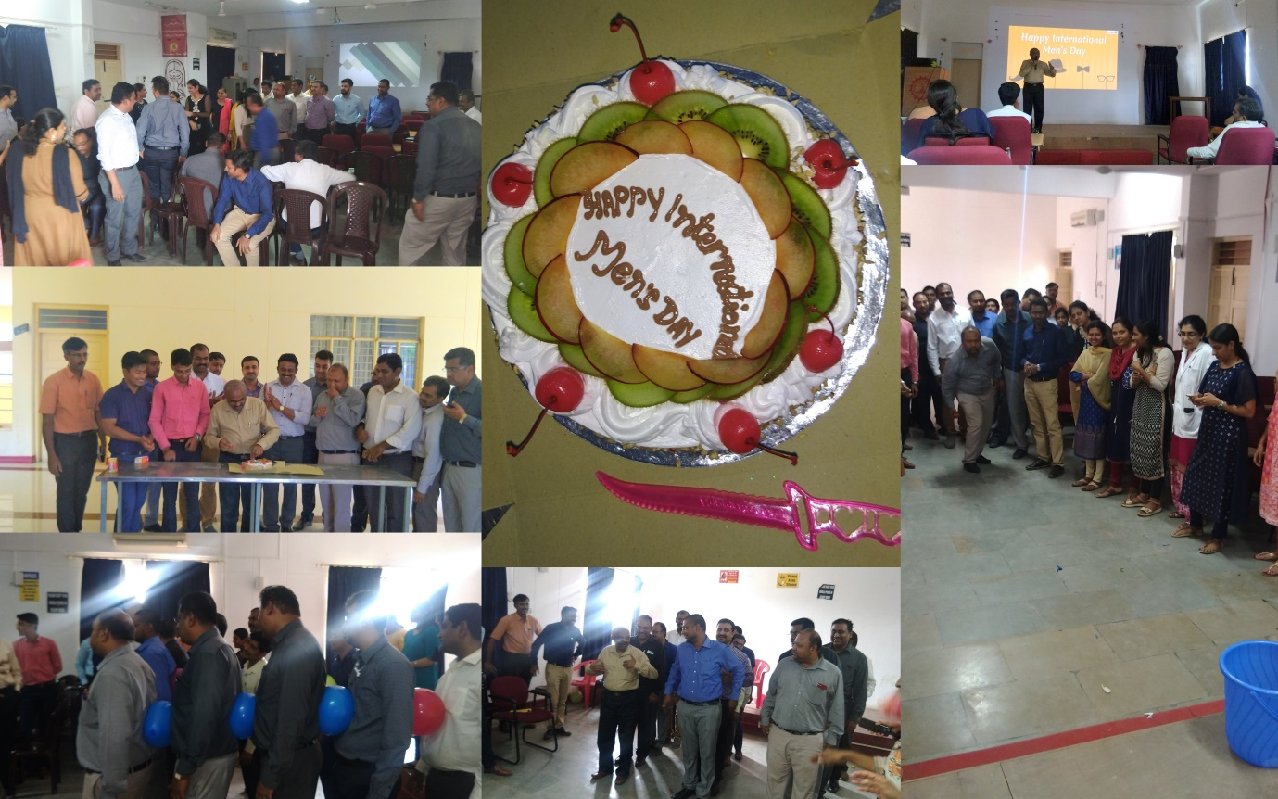

Kannada Rajyotsava – 2019
On 12/11/2019 a colourful and memorable “Kannada Rajyotsava” was organized in our institution. The grand event commenced with welcome address by Dr.Kokila, Chaiperson, Committee for Cultural & Co-curricular activities followed by invocation song, lighting of lamp. Principal Dr. K R Kashinath addressed the gathering shared his thoughts, importance of Rajyotsava and Karanataka. The staff and students performed dance performances and singing of songs. There was group dance by staff and 1st BDS students. Singing performance by staff Dr.Pavana&Dr.Preeti, Dr.Laxmidevi and non-teaching staff Shivamma. There was event from Non-Kannadigas – kannada songs were sung by Toriya of 3rd BDS. Anthyakshari game was played in which the staff were to sing kannada songs. The program ended with” nada geete” sung by Moulya, Sharvani, Priyanka of 2nd BDS. Then the event was followed by vote of thanks. There was band performance arranged by professional band performers at the reception area of the college, near Buddha statue. A light meal of authentic “coconut obbattu”, rice, mirjibajji and curd rice was arranged for all the staff and students. All the teaching staff, non-teaching staff and students really enjoyed a lot and dispersed with a feeling that such mega events should be organized every year.

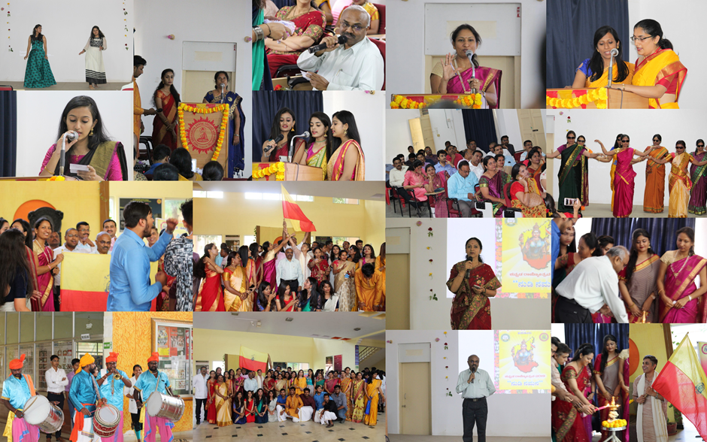

(DR.G.Kokila) (Dr.SanjayVenugopal) (Dr.-------------------)
Chairperson Co-ordinator IQAC chairperson/
Committee for culturalHuman Resources Principal
& co-curricular activities

